CNM Grant Procurement Memo
Applies to:
Funding source (choose one):
State Federal
- Federal purchases $10,000 and above or,
- State purchases $20,000 and above
- Purchases less than $60,000
Grant/Project Title:CNMI/CNM HED GRO FY26 Equipment Distribution
Project Director/PI: Brian Rashap
Grant number within Workday: GR300513
Description of goods or services: Short description of what is needed
Portable Spectral Analyzer

Benefit to grant and CNM: Describe how/why this purchase will meet objectives of project.

Required to ensure that signal generators and modulators are providing correct frequencies for laser cooling.

Estimated dollar amount: $ 21,711.94

Rationale for method of procurement: Describe how quotes were gathered
Direct quote and online pricing
Contractor selection or rejection: Name each vendor and indicate whether selected or rejected. This will document and justify the decision for procurement.

- VENDOR #1: Keysight
  - Keysight: ACCEPTED
  - Amount of Quote: $ 21,711.94
  - Justification: Has required resolution. Portability enables on system to be used on all four MOTs in the quantum lab, so that multiple need to be purchased.

- VENDOR #2: TEST EQUITY
  - Vendor 2: Rejected
  - Amount of Quote: $16,830
  - Justification: Size and fixed nature would require two in the quantum learning lab to support all four MOTs.

- VENDOR #3: NEWARK
  - Vendor 3: Rejected
  - Amount of Quote: 25,133.00
  - Justification: Meet resolution and portability requirements, more expensive

Vendor #1:
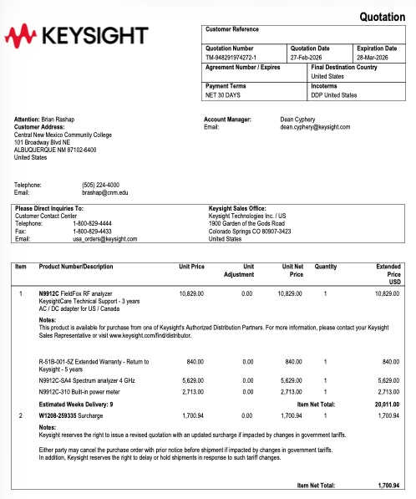
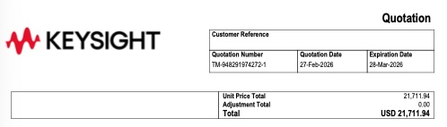

Vendor #2
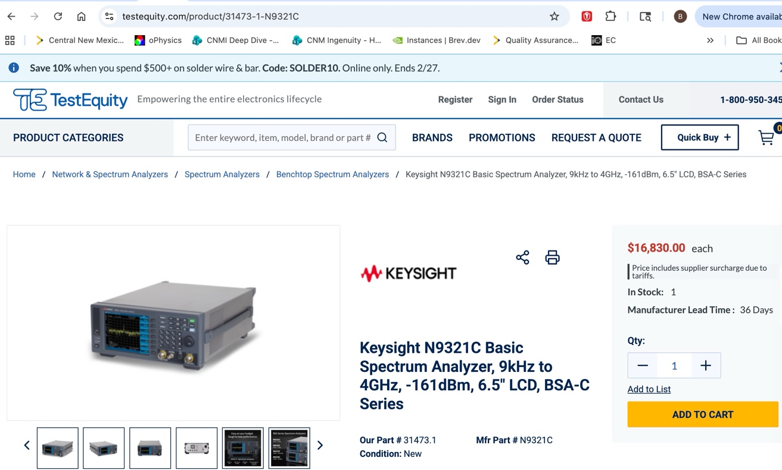
Vendor #3:
